30th April 2018

WTCR - Veteran Tarquini beats Home favourite in Hungary

The Italian veteran Gabrielle Tarquini maintains the leadership in the Championship with a win ahead of home hero Michelisz.

Gabriele Tarquini broke the hearts of the dedicated Hungaroring faithful at WTCR Race of Hungary by beating national hero and team-mate Norbert Michelisz to victory, as the WTCR – FIA World Touring Car Cup put on a gripping display of action-packed racing at the weekend. The series which boasts the Japanese premium tyre manufacturer YOKOHAMA as exclusive tyre supplier, is intense, open, and extremely competitive so far.

This time, the key was the Italian veteran’s trademark explosive start that allowed him to streak ahead of Pole Position driver, Michelisz before they braked for Turn 1. In a race interrupted firstly by a safety car and then a red flag because of rain, Tarquini kept his cool and extended his WTCR points lead over second-placed Yann Ehrlacher as the BRC Racing Team claimed a resounding one-two with its Hyundai i30 N TCRs.

Earlier in the day, Sébastien Loeb Racing’s Rob Huff converted his Pole Position into a reverse grid Race 2 victory. Driving a Volkswagen Golf GTI TCR, the Briton withheld an impressive challenge from wildcard entry Dániel Nagy, who capped a competitive weekend with a podium in his M1RA-entered Hyundai.

Huff’s win means four of the seven car brands represented in the all-new WTCR have tasted victory after just six races, following Yann Ehrlacher’s Race 1 success on Saturday. The Frenchman climbed from fifth on the grid to the lead in just two corners to deliver ALL-INKL.COM Münnich Motorsport a first victory with its Honda Civic Type R TCR. He then landed the TAG Heuer Best Lap Trophy for his rapid display in Race 3.

Yvan Muller left Hungary with two thirds in WTCR for his self-run team but it would prove a weekend to forget for his team-mate Thed Björk, who had to make do with two ninth-place finishes in his YMR Hyundai.

Eighteen-year-old Benjamin Lessenes impressed with fifth place in Race 3 for Boutsen Ginion Racing. Jean-Karl Vernay finished in the points in all three races for the Audi Sport Leopard Lukoil Team, while former simracing champion Zsolt Szabó was ninth in Race 2 for MOL-supported Zengő Motosport. After finishing second in Race 1 and fifth in Race 2, a jumped start in Race 3 earned Esteban Guerrieri a drive-through penalty.
The next rounds in the WTCR will be held at the legendary Nürburgring, Germany 10th-12th May.

Driver Standings
G Tarquini 118
Y Erlacher 82
Y Muller 77

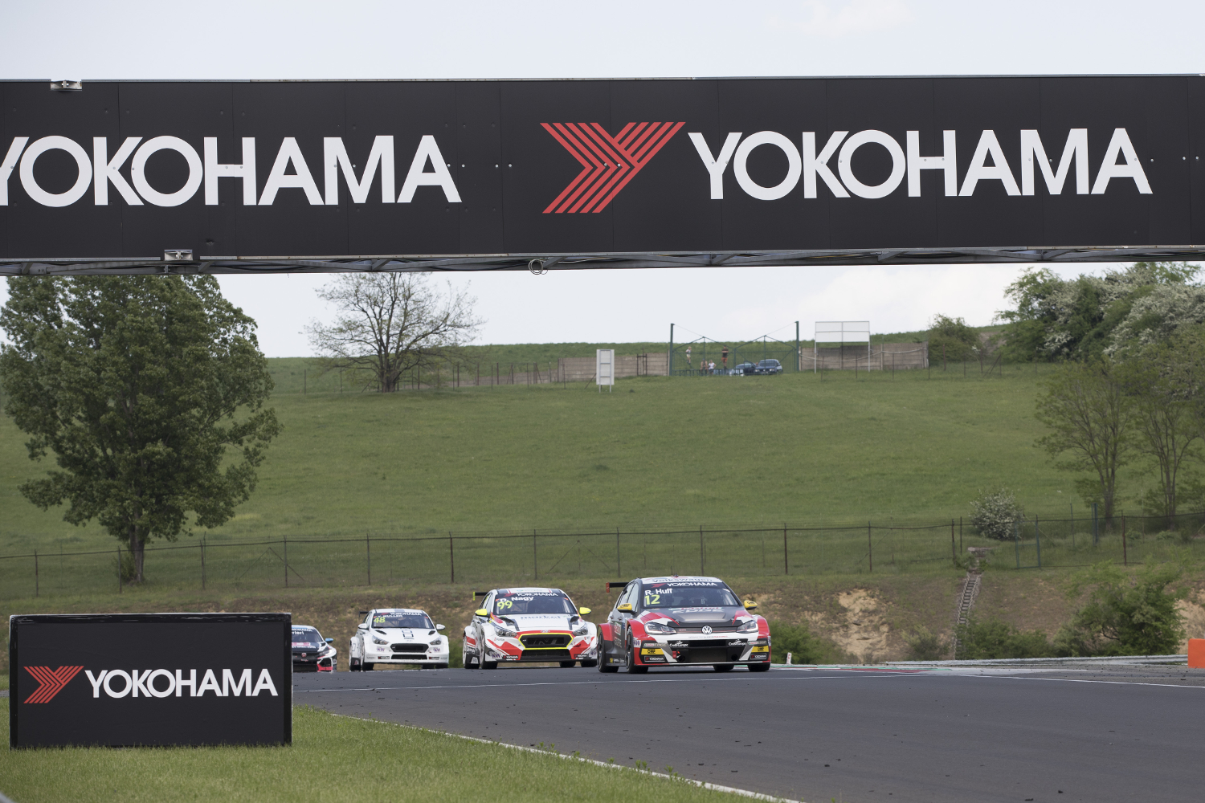
Excitement at the Hungaroring with WTCR and YOKOHAMA Photo Gregory Lenormand DPPI

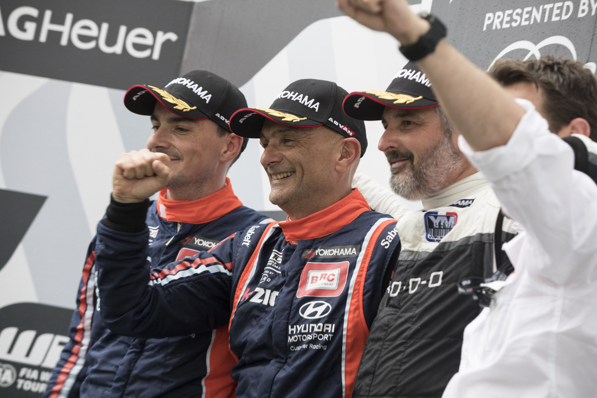
Smiles all around for Italian Veteran Tarquini Photo Gregory Lenormand DPPI

